Regulatory Committee
Meeting to be held on 17th January 2018

Electoral Division affected:
Wyre Rural East

Wildlife and Countryside Act 1981
Definitive Map Modification Order Investigation
Addition of footpath at Calder Vale, Wyre Borough
File No. 804-587
(Annex ‘A’ refers)

Contact for further information:
Claire Blundell, 01772 535604, County Secretary and Solicitors Group, legalservicesPROW@lancashire.gov.uk
Jayne Elliott, 01772 537663, Public Rights of Way Definitive Map Officer,
Planning and Environment, jayne.elliott@lancashire.gov.uk

Executive Summary

Application for the addition to the Definitive Map and Statement of a footpath from Albert Terrace passing through The Holme and continuing adjacent to a pond to meet Footpath 80 Barnacre with Bonds, Wyre Borough in accordance with File No. 804-587.

Recommendation

- That the application for a public footpath to be added to the Definitive Map
and Statement from Footpath 80 Barnacre with Bonds at Albert Terrace, passing through The Holme (Calder Vale) and continuing alongside a pond to rejoin Footpath 80, Barnacre with Bonds, Wyre Borough, in accordance with File No. 804-587, be accepted.

- That an Order be made pursuant to Section 53 (2)(b) and Section 53 (3)(b)

and/or Section 53 (3)(c)(i) of the Wildlife and Countryside Act 1981 to add to the Definitive Map and Statement of Public Rights of Way a footpath from a point on Footpath 80 Barnacre with Bonds at Albert Terrace, passing through The Holme and continuing adjacent to a pond to rejoin Footpath 80 Barnacre with Bonds as shown on Committee Plan between points A-B-C-D-E.

- That being satisfied that the higher test for confirmation can be met the Order

be promoted to confirmation.

Background

An application under Schedule 14 of the Wildlife and Countryside Act 1981 has been received for the addition to the Definitive Map and Statement of Public Rights of Way of a footpath from a point on Footpath 80 Barnacre with Bonds at Albert Terrace passing through The Holme and running adjacent to a pond to rejoin Public Footpath 80 Barnacre with Bonds, Wyre Borough.

The County Council is required by law to investigate the evidence and make a decision based on that evidence as to whether a public right of way exists, and if so its status. Section 53(3)(b) and (c) of the Wildlife and Countryside Act 1981 set out the tests that need to be met when reaching a decision; also current Case Law needs to be applied.

An order will only be made to add a public right of way to the Definitive Map and Statement if the evidence shows that:

- A right of way “subsists” or is “reasonably alleged to subsist”

An order for adding a way to or upgrading a way shown on the Definitive Map and Statement will be made if the evidence shows that:

- “the expiration… of any period such that the enjoyment by the public…raises a presumption that the way has been dedicated as a public path or restricted byway”

When considering evidence, if it is shown that a highway existed then highway rights continue to exist (“once a highway, always a highway”) even if a route has since become disused or obstructed unless a legal order stopping up or diverting the rights has been made. Section 53 of the Wildlife and Countryside Act 1981 (as explained in Planning Inspectorate’s Advice Note No. 7) makes it clear that considerations such as suitability, the security of properties and the wishes of adjacent landowners cannot be considered. The Planning Inspectorate’s website also gives guidance about the interpretation of evidence.

The County Council’s decision will be based on the interpretation of the evidence discovered by officers and documents and other evidence supplied by the applicant, landowners, consultees and other interested parties produced to the County Council before the date of the decision. Each piece of evidence will be tested and the evidence overall weighed on the balance of probabilities. It is possible that the Council’s decision may be different from the status given in any original application. The decision may be that the routes have public rights as a footpath, bridleway, restricted byway or byway open to all traffic, or that no such right of way exists. The decision may also be that the routes to be added or deleted vary in length or location from those that were originally considered.

Consultations

Wyre Borough Council

Wyre Borough Council have been consulted and no response has been received, it is assumed they have no comments to make.

Barnacre with Bonds Parish Council

A letter written by the Clerk of the Parish Council was submitted as part of the application. The letter stated that the Parish Council fully supported the application, and that the route accessed from land between 9 and 10 The Holme, running along the mill pond to join the public footpath to Primrose Cottages had been used by locals for over 70 years.

Applicant/Landowners/Supporters/Objectors

The evidence submitted by the applicant/landowners/supporters/objectors and observations on those comments are included in Advice – Head of Service – Legal and Democratic Services Observations.

Advice

Head of Service – Planning and Environment

Points annotated on the attached Committee plan.

Point | Grid Reference (SD) | Description
A | 5320 4571 | Junction with Footpath 80 Barnacre with Bonds adjacent to Albert Terrace
B | 5321 4562 | End of access road west of 1 The Holme
C | 5324 4557 | Pedestrian gate (blocked)
D | 5319 4549 | Sluice
E | 5314 4545 | Junction with Footpath 80 Barnacre with Bonds

Description of Route

A site inspection was carried out on 14 June 2017.

The application route commences on Albert Terrace at an unmarked point on Footpath 80 Barnacre with Bonds, approximately 25 metres from its junction with Calder Vale Road (point A on the Committee plan).

From point A, the route extends in a south south easterly direction past the end of Albert Terrace along a rough tarmac access road, which descends steeply downhill past Calder House towards a cluster of houses known collectively as The Holme.

The route passes directly to the west of 1 The Holme where the access road ends at point B and then continues across a large open tarmac area which provides direct access to the houses built around three sides of it. On the day the route was inspected, a number of cars were parked outside the houses but none where parked directly across the application route.

From point B, the application route takes a direct route across the open area passing in a south easterly direction between 9 and 10 The Holme from where it then continues across an area of rough grass to a blocked off gateway at point C.

Beyond point C the route continues with a trodden path visible in the grass along a strip of land between a pond and the River Calder.

At point D the route crosses a sluice which allows water to drain from the pond into the river although it was not possible to determine whether the sluice was still operational.

Beyond point D the application route continues adjacent to the pond along a more clearly defined trodden path ascending gently uphill as it reaches the southern end of the pond and exiting onto Footpath 80 at point E.

At point E access to and from the application route is open with fencing and wooden rails delineating the line of the application route but not crossing it. A sign at point E states 'Private Land No Public Right of Way'.

The total length of the route is 315 metres.

Map and Documentary Evidence

Calder Vale lies on the River Calder in a deep valley with only a single road providing access to it.
The village was founded by Quakers Jonathan and Richard Jackson and in 1835 a cotton-weaving mill — the Lappet Mill — powered by the River Calder was built to the north of the application route. The Jackson brothers also built many of the terraced houses still in occupation close to the mills.
Prior to the construction to the mill and associated cottages there was no indication on any of the early commercial maps that the village existed and no road is shown leading into the area.
Early commercial maps predating the construction of the mill were checked (Yate's Map 1786, Greenwoods Map 1818, Hennet's Map 1830) but none show the road leading down to the mill, the village itself or the application route so research into the history of the application route has been limited to records dating from the construction of the village (1835) to the current day.

Document Title | Date | Brief Description of Document & Nature of Evidence
Tithe Map and Tithe Award or Apportionment | 1839 and 1846 | Maps and other documents were produced under the Tithe Commutation Act of 1836 to record land capable of producing a crop and what each landowner should pay in lieu of tithes to the church. The maps are usually detailed large scale maps of a parish and while they were not produced specifically to show roads or public rights of way, the maps do show roads quite accurately and can provide useful supporting evidence (in conjunction with the written tithe award) and additional information from which the status of ways may be inferred.
1839
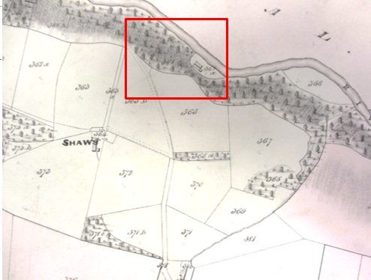
Observations |  | The Tithe Map deposited in the County Records Office was dated 1839. A further reference was listed for a map produced in 1846 but this map could not be found by the archivists.  The application route is not shown on the map prepared in 1839 and the cottages forming The Holme and the mill pond are not shown.
Investigating Officer's Comments |  | The application route did not exist in 1839.
6 Inch Ordnance Survey (OS) Map | 1846 | The earliest Ordnance Survey 6 inch map for this area surveyed in 1844 and published in 1846.
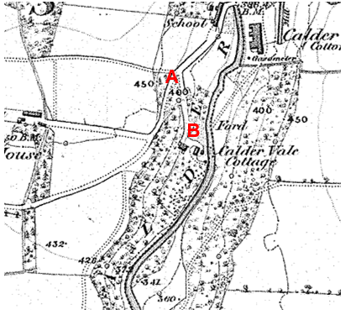
Observations |  | The application route between point A and point B can be seen as a significant route providing access to buildings located where The Holme is now situated. Albert Terrace is not shown and neither is the pond or the route of Footpath 19 Barnacre with Bonds to which the application route joins at point E.
Investigating Officer's Comments |  | The application route existed in 1844 (date of survey) between point A and point B providing access to Calder Vale Cottage but no further.
25 Inch OS Map | 1892 | The earliest OS map at a scale of 25 inch to the mile. Surveyed in 1890-91 and published in 1892.
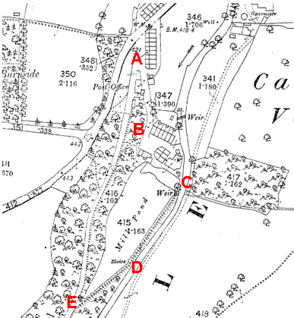
Observations |  | Albert Terrace is shown (but not named) and the application route is shown from point A to point B as partly enclosed route open to the general highway network and providing access to The Holme (not named). Between point B and point C the application route is not shown and crosses 2 boundary features but access appears to have been available close to the application route but not along the exact same route. There is a line across the route at the weir but not across the embankment at point C.  The pond is shown and labelled as 'Mill Pond'. From the weir down to the sluice at point D the application route is shown as a dashed line along the top of the embankment which separates the pond from the River Calder. The embankment continues from point D with a dashed line along the top to point E where it meets the track now recorded as Footpath 80.
Investigating Officer's Comments |  | The application route appears to have existed between points A and B and points C and E in 1890-91 although it is not clear how it crossed the weir. A route between point B and point C – linking the two parts of the application route also appears to have been available but along a slightly different route.
25 inch OS Map | 1912 | Further edition of the 25 inch map surveyed in 1890-91, revised in 1910 and published in 1912.
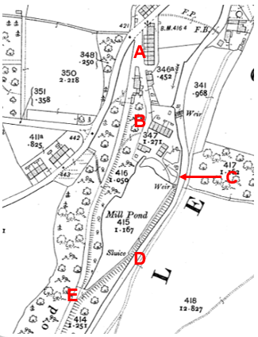
Observations |  | The application route between points A and B is shown and the houses comprising The Holme are all shown to exist. The application route between points B and C is not shown and access along the full length of the line claimed does not appear to be possible due to fencing that has changed since the 1890s near point C. Two slightly different routes from The Holme to the weir and east side of the mill pond do however appear to exist – one which appears to be defined by fencing and passes between the properties close to the alignment of the application route but slightly to the south of C and the other which runs to the rear of The Holme adjacent to the river bank.  From the weir south of point C through to point E a path is shown along the top of the embankment.
Investigating Officer's Comments |  | Most of the application route appears to have been capable of being used in 1910 except near point C where access differed from the application route.
Finance Act 1910 Map | 1910 | The comprehensive survey carried out for the Finance Act 1910, later repealed, was for the purposes of land valuation not recording public rights of way but can often provide very good evidence. Making a false claim for a deduction was an offence although a deduction did not have to be claimed so although there was a financial incentive a public right of way did not have to be admitted.  Maps, valuation books and field books produced under the requirements of the 1910 Finance Act have been examined. The Act required all land in private ownership to be recorded so that it could be valued and the owner taxed on any incremental value if the land was subsequently sold. The maps show land divided into parcels on which tax was levied, and accompanying valuation books provide details of the value of each parcel of land, along with the name of the owner and tenant (where applicable).  An owner of land could claim a reduction in tax if his land was crossed by a public right of way and this can be found in the relevant valuation book. However, the exact route of the right of way was not recorded in the book or on the accompanying map. Where only one path was shown by the Ordnance Survey through the landholding, it is likely that the path shown is the one referred to, but we cannot be certain. In the case where many paths are shown, it is not possible to know which path or paths the valuation book entry refers to. It should also be noted that if no reduction was claimed this does not necessarily mean that no right of way existed.
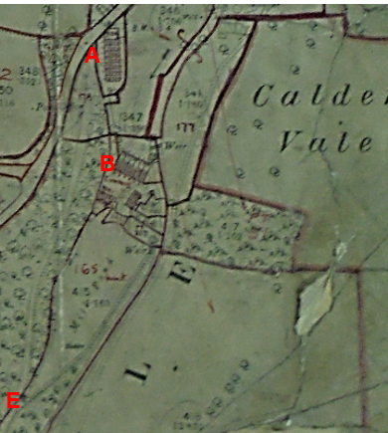
Observations |  | There is no Finance Act map available to view at the County Records Office. A poor quality map has been deposited at the National archives but is very difficult to interpret.  From looking at the map and trying to enlarge the image it appears that the area immediately around Albert Terrace has been excluded from the numbered hereditaments including a short section of the application route from point A.  Most of the route between point A and point C however looks to be included in numbered plots although it is difficult to identify the numbers.  From the weir just south of point C through to point E the route is included in hereditament 164 and the Field Book deposited in the National Archives lists the owners as being Caldervale Cotton Mill with no deductions documented for public rights of way or user.
Investigating Officer's Comments |  | No inference can be drawn regarding the application route between point A and point C.  From the weir just south of point C through to point E the owners of the land did not acknowledge the existence of any public rights over the land crossed by the application route at the time of the valuation.
Aerial Photograph | 1940s | The earliest set of aerial photographs available was taken just after the Second World War in the 1940s and can be viewed on GIS. The clarity is generally very variable.
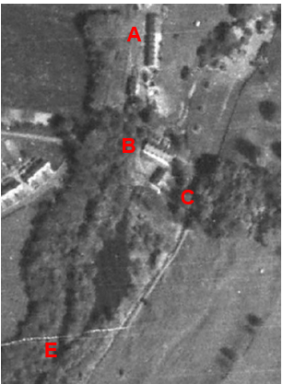
Observations |  | It is difficult to see whether much of the application route existed due to the scale of the photograph and the presence of trees and vegetation obscuring what may have been present on the ground. Albert Terrace can be seen and parts of the route between points A and B are visible. From point B a route is visible which is largely consistent with the application route running between the properties and along the south side of 9 The Holme from where two faint lines can be seen – one towards point C and one just south east of point C and both leading towards the application route.  The mill pond is not apparent on the photograph and it looks like it may have become overgrown and vegetated in the 1940s. A line can be seen from the east side of the river crossing the river and running towards and past point E but it is not clear whether this is a scratch on the photo rather than a feature on the ground. It is not clear whether the application route from point C to point E existed at this time due to the vegetation cover and poor quality of the photograph.
Investigating Officer's Comments |  | At least parts of the application route existed in the 1940s but it is not possible to determine whether the whole route was accessible.
6 Inch OS Map | 1956 | The OS base map for the Definitive Map, First Review, was published in 1956 at a scale of 6 inches to 1 mile (1:10,560). This map was revised before 1930 and is probably based on the same survey as the 1930s 25-inch map.
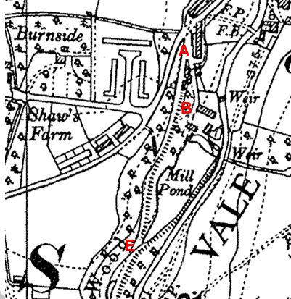
Observations |  | This small scale map shows the application route providing access to properties between point A and point B but does not show whether access would have been available between points B-C-D-E.
Investigating Officer's Comments |  | The application route existed between point A and point B but the scale of the map means that no inference can be drawn with regards to the existence of the rest of the route in the 1930s.
1:2500 OS Map | 1961 | Further edition of 25 inch map reconstituted from former county series and revised in 1960 and published 1961 as national grid series.
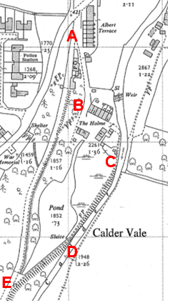
Observations |  | The application route between point A and point B can be clearly seen and passes a building midway the two points which is now known as Calder House but which is marked on the 1960s map as a post office (P.O.) although it is not clear whether this would have been accessed from the application route or from Footpath 80.  Access looks like it may have been available between point B and point C but a route is not shown suggesting that there was no worn track on the ground.  Of significance is the fact that a route is marked from the end terrace – 6 The Holme – leading to the river and then south to the rear of 7,8 and 9 The Holme to point C from where a route is shown as a double pecked line along the embankment annotated 'FP' (footpath) through to point E where it joins the track recorded as Footpath 80.  The mill pond is labelled pond and is significantly smaller than it had been in the early 1900s suggesting that significant silting up had taken place leaving a significant part of it as marshy land adjacent to the application route between point C and point D.
Investigating Officer's Comments |  | The application route existed between points A and B and between points C and E. The route may have been accessible between points B and C along the line claimed but there was also a more clearly defined route to the east of 7,8 and 9 The Holme.
Aerial photograph | 1960s | The black and white aerial photograph taken in the 1960s and available to view on GIS.
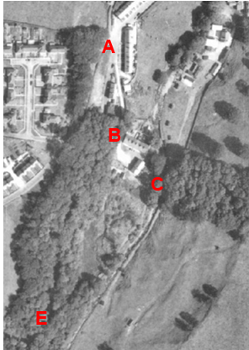
Observations |  | Tree cover obscures large parts of the route but the photograph appears to show that the main access to the building marked on the 1960s OS as a post office was from the application route. The application route can be seen between points A and B and from point B it looks like it may have been possible to walk the application route through to point C.  A faint line consistent with part of the route between points C-D-E can be seen but the full length is not evident due to tree cover. The pond cannot be seen and appears to be largely vegetated.
Investigating Officer's Comments |  | The application route may have existed in the 1960s.
Aerial Photograph | 1988 | Aerial photograph available to view in the County Records Office
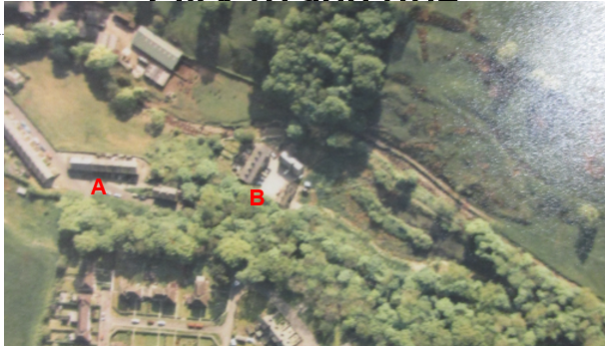
Observations |  | Tree cover again obscures parts of the route and only part of the route between points A and B is visible. From point B across the forecourt of The Holme the route claimed appears available towards point C. The mill pond is visible but appears to be much smaller than it was originally and much smaller than it is currently. A worn route appears to extend from The Holme to the application route between point C and point D but does not appear to be on the same line as claimed. The rest of the application route cannot be seen due to tree cover.
Investigating Officer's Comments |  | The application route between points A and B probably existed in 1988. Between points B and C the route across The Holme appears available but from the northern corner of 9 The Holme the route may have differed from the alignment of the route claimed as the Mill pond appeared to be much smaller and the land south of The Holme did not appear to be fenced or marked out in the same way as it is now.
Google Earth photograph | 2000 | Photograph submitted by one of the landowners.
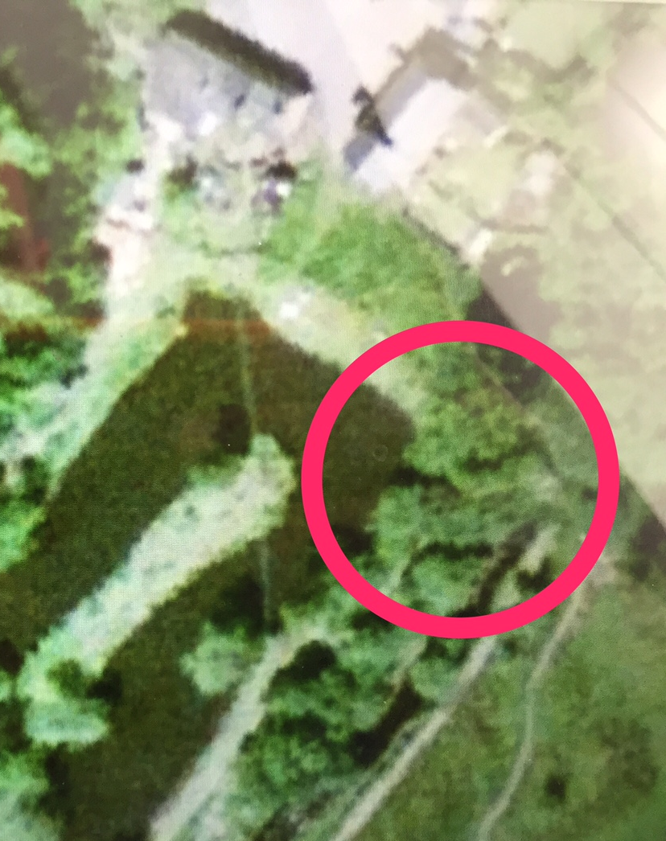
Observations |  | The photograph shows a faint line consistent with the application route from the side of 9 The Holme through to the proximity of point C and beyond. The applicant had circled an area which he described as the sluice and that there was no access across it. He also referred to the excavation of the pond which accounted for the tracks which could be seen.
Investigating Officer's Comments |  | The application route may have been accessible at that time and the faint line extending from the Holme to point C and point beyond appears consistent with pedestrian use.
Extract from Sales Particulars for 6 Primrose Cottage | 2010 | Extract of RightMove Sales particulars for 6 Primrose Cottage attached to one of the user evidence forms submitted as part of the application and dated 2 September 2010.
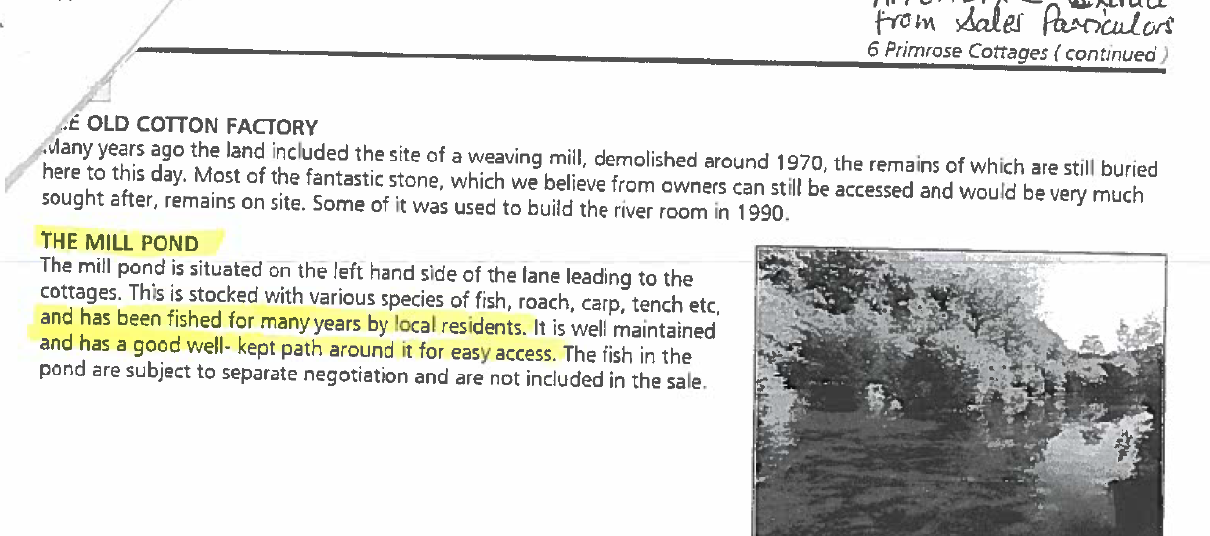
Observations |  | A full copy of the Sale Particulars was not provided but from the information provided it appears that the pond – referred to as the Mill Pond – was included in the sale. There is reference to the existence of a well maintained path around the pond 'for easy access' but there is no indication whether this access was regarded as being public or private.
Investigating Officer's Comments |  | A Land Registry search revealed that 6 Primrose Cottage was last sold in 2012 and that the sale did not include anything other than the cottage and garden.  That part of the application route around the mill pond appears to have existed as a well maintained path in 2010 but no inference can be drawn regarding public rights.
Land Registry Plans |  | Land Registry plans relating to a number of properties at The Holme were inspected in relation to comments made concerning the provision of parking spaces.
Title Plans filed under title LA956239
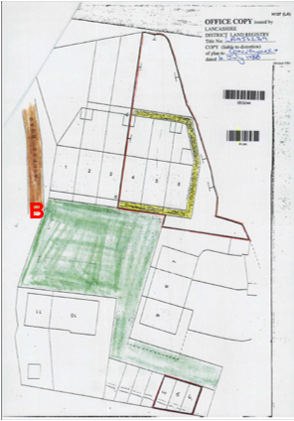
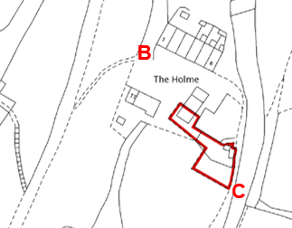
Title Plan LA810907
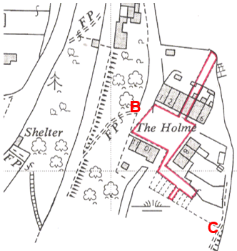
Observations |  | The title for 9 The Holme (LA956239) provides details that the property was registered to the current owner in 2004. The plan coloured plan shows the marked out car parking spaces which were allocated to the various properties. A further Land Registry plan included in this report also
Investigating Officer's Comments |  | The plans show the marked out parking areas hand drawn with solid lines on the coloured plan but marked by dashed lines on the OS based plan. It appears that the plots were allocated for parking but were not necessarily physically marked out by fencing/walls which would have been indicated by solid lines on the OS plans.  It is unlikely that the parking areas existed when the properties were originally constructed but more likely that they have been marked out either physically or on maps in more modern times due to the increase in the use and ownership of vehicles.  It appears that pedestrians using the route between points B and C may have passed to the north of the parking spaces although may have been impeded by parked cars at times but that it would have been possible to walk round them.
Aerial Photograph | 2014 | Aerial photograph available to view on GIS.
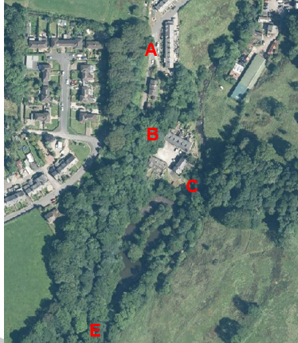
Observations |  | Most of the route is obscured by tree cover. A route across forecourt of The Holme appears available.
Investigating Officer's Comments |  | No inference can be drawn with regards to most of the application route.
Definitive Map Records |  | The National Parks and Access to the Countryside Act 1949 required the County Council to prepare a Definitive Map and Statement of Public Rights of Way.  Records were searched in the Lancashire Records Office to find any correspondence concerning the preparation of the Definitive Map in the early 1950s.
Parish Survey Map | 1950-1952 | The initial survey of public rights of way was carried out by the parish council in those areas formerly comprising a rural district council area and by an urban district or municipal borough council in their respective areas. Following completion of the survey the maps and schedules were submitted to the County Council. In the case of municipal boroughs and urban districts the map and schedule produced, was used, without alteration, as the Draft Map and Statement. In the case of parish council survey maps, the information contained therein was reproduced by the County Council on maps covering the whole of a rural district council area. Survey cards, often containing considerable detail exist for most parishes but not for unparished areas.
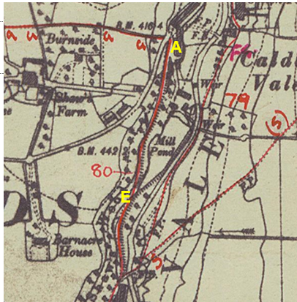
Observations |  | The Parish Survey map and cards were drawn up by Barnacre with Bonds Parish Council. The application route is not shown on the parish survey map or documented in the parish survey cards.
Draft Map |  | The parish survey map and cards for Barnacre with Bonds were handed to Lancashire County Council who then considered the information and prepared the Draft Map and Statement.  The Draft Maps were given a “relevant date” (1st January 1953) and notice was published that the draft map for Lancashire had been prepared. The draft map was placed on deposit for a minimum period of 4 months on 1st January 1955 for the public, including landowners, to inspect them and report any omissions or other mistakes. Hearings were held into these objections, and recommendations made to accept or reject them on the evidence presented.
Observations |  | The application route is not shown on the Draft Map of Public Rights of Way and there were no objections to the omission of the path.
Provisional Map |  | Once all representations relating to the publication of the draft map were resolved, the amended Draft Map became the Provisional Map which was published in 1960, and was available for 28 days for inspection. At this stage, only landowners, lessees and tenants could apply for amendments to the map, but the public could not. Objections by this stage had to be made to the Crown Court.
Observations |  | The application route is not shown on the Provisional Map of Public Rights of Way and there were no objections to the omission of the path.
The First Definitive Map and Statement |  | The Provisional Map, as amended, was published as the Definitive Map in 1962.
Observations |  | The application route is not shown on the First Definitive Map and Statement Map.
Revised Definitive Map of Public Rights of Way (First Review) |  | Legislation required that the Definitive Map be reviewed, and legal changes such as diversion orders, extinguishment orders and creation orders be incorporated into a Definitive Map First Review. On 25th April 1975 (except in small areas of the County) the Revised Definitive Map of Public Rights of Way (First Review) was published with a relevant date of 1st September 1966. No further reviews of the Definitive Map have been carried out. However, since the coming into operation of the Wildlife and Countryside Act 1981, the Definitive Map has been subject to a continuous review process.
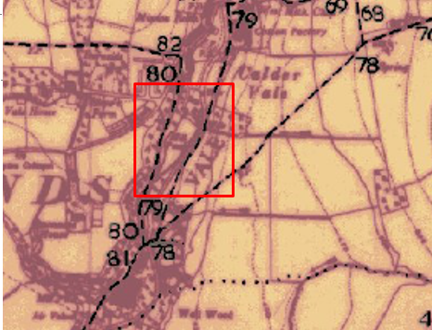
Observations |  | The application route is not shown on the Revised Definitive Map and Statement of Public Rights of Way (First Review).
Investigating Officer's Comments |  | The application route was not considered to be public during the preparation of the 1st Definitive Map and Statement through to the 1960s.
Highway Adoption Records including maps derived from the '1929 Handover Maps' | 1929 to present day | In 1929 the responsibility for district highways passed from district and borough councils to the County Council. For the purposes of the transfer, public highway 'handover' maps were drawn up to identify all of the public highways within the county. These were based on existing Ordnance Survey maps and edited to mark those routes that were public. However, they suffered from several flaws – most particularly, if a right of way was not surfaced it was often not recorded.  A right of way marked on the map is good evidence but many public highways that existed both before and after the handover are not marked. In addition, the handover maps did not have the benefit of any sort of public consultation or scrutiny which may have picked up mistakes or omissions.  The County Council is now required to maintain, under section 31 of the Highways Act 1980, an up to date List of Streets showing which 'streets' are maintained at the public's expense. Whether a road is maintainable at public expense or not does not determine whether it is a highway or not.
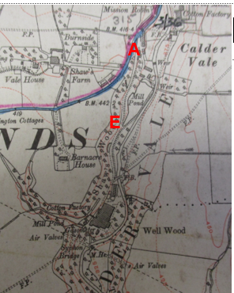
Observations |  | The route under investigation is not recorded as being publicly maintainable in the records originally derived from the 1929 Handover Maps and now held by the County Council.
Investigating Officer's Comments |  | The fact that it is not recorded as a publicly maintainable highway does not mean that it does not necessarily carry public rights of access.
Statutory deposit and declaration made under section 31(6) Highways Act 1980 |  | The owner of land may at any time deposit with the County Council a map and statement indicating what (if any) ways over the land he admits to having been dedicated as highways. A statutory declaration may then be made by that landowner or by his successors in title within ten years from the date of the deposit (or within ten years from the date on which any previous declaration was last lodged) affording protection to a landowner against a claim being made for a public right of way on the basis of future use (always provided that there is no other evidence of an intention to dedicate a public right of way).  Depositing a map, statement and declaration does not take away any rights which have already been established through past use. However, depositing the documents will immediately fix a point at which any unacknowledged rights are brought into question. The onus will then be on anyone claiming that a right of way exists to demonstrate that it has already been established. Under deemed statutory dedication the 20 year period would thus be counted back from the date of the declaration (or from any earlier act that effectively brought the status of the route into question).
Observations |  | There are no Highways Act 1980 Section 31(6) deposits lodged with the County Council for the area of land over which the route under investigation runs.
Investigating Officer's Comments |  | There is no indication by a landowner under this provision of non-intention to dedicate public rights of way over their land.

The affected land is not designated as access land under the Countryside and Rights of Way Act 2000 and is not registered common land.

Landownership

The majority of the land between points A and B is registered to Ms Audrey Holden of Calder House, Albert Terrace, Calder Vale, Preston, PR3 1SA, with the lower part (to the north of point B) unregistered.

The land between points B and C is registered to Mr and Mrs McIntosh of 4 The Holme, Calder Vale, Preston, PR3 1SB and Mr Roger Davies of 9 The Holme, Calder Vale, Preston, PR3 1SB.

The majority of the land between Points C and D is owned jointly by Mr Justin Hall of 29 Elmhurst Road, Lytham St Annes, FY8 3JH and Mr Gregson of 149 Preston Road, Lytham St Annes, FY8 5AY. A small parcel of land to the south of point C and to the north of point E is unregistered but is believed to be owned by Mssrs Hall and Gregson.

Summary

There appears to be no map and documentary evidence which provides a clear and consistent view that the application route was created or formally dedicated as a public footpath.

Prior to the construction of the village in the 1830s the application route did not exist.

By 1846 the route between point A and point B existed as access to Calder Vale cottage and by 1896 The Holme is shown to exist together with the mill pond and it appears that by that time access may have been available along the full length of the application route providing access to the Holme and via the Holme to the access road to Lower Mill which is consistent with the view that the route originally provided access to the mill from the cottages provided for the workers on Albert Terrace and The Holme.

From studying subsequent map revisions there appears to have been very little alteration to the land crossed by the application route – or to the application route itself – from the late 1800s to the current day.

However, the route through the Holme – from point B to point C – is not clearly shown or defined on the maps inspected and whilst access appears to have generally been available along the route claimed, neither the maps or aerial photographs inspected are conclusive with regards to the exact route taken, or whether this route may have varied slightly depending on temporary features or parked cars. A clearly defined route is shown on the 1:2500 OS map published in 1961 to the rear of 7,8,9 The Holme which is different to the route claimed although it may have been possible to walk the claimed route at this time.

Head of Service – Legal and Democratic Services Observations

Information from the Applicant

The applicant originally applied for a route from between 9 and 10 The Holme to point E to be recorded as a public footpath but did not include the section of the route between points A-B or part of the route between points B-C.

Following discussion with the applicant it was understood that she had only claimed the route from The Holme to point E because that was the section of path to which access had been prevented and that she had not realised that it was necessary to claim the full length.

The application was subsequently revised to include the full length between points A-B-C-D-E.

The application was supported by:

- A brief introduction and photographs showing the site dated 2017.
- An emailed statement from the previous owners of the Mill Pond stating that they had always been happy to let people use the route.
- A letter of support from Barnacre with Bonds Parish Council.
- Various maps showing the footpath marked.
- 34 user evidence forms.

As part of the application, the applicants provided a copy of an email that they had sent to the former owners of part of the land crossed by the application route - Revered Canon Noel Michell and Mrs Lesley Michell.

Mrs Michell has responded to their request for information explaining that they had owned that part of the valley from sometime in the late 1980s (that parcel was registered to them at the Land Registry on 18.5.1990) until the whole of their land holding was sold by them to Justin Hall (the current landowner).

Mrs Michell wrote, 'We understood from the outset, when we bought 6 Primrose Cottage in 1981, that the path from The Holme, running beside the lodge from Primrose Cottages, was historically a path used by locals, dating from the time of the operation of Low Mill, when workers used it as a route to and from work. Once we had bought that piece of land we were happy to continue that accepted right of way. Neither we nor the people who leased the lodge from us for a number of years ever closed the path or put up notices forbidding access.'

The comments made by the Parish Council in support of the application have already been documented earlier in the report and the various maps submitted have been considered by the Environment and Planning Group Investigating Officer.

The thirty four user evidence statements submitted with the application referred specifically to the route described as running from between 9 and 10 The Holme to point E on the Committee plan. 30 of the users subsequently confirmed – by way of a signed plan on which they had drawn the full length of the route A-E that their evidence related to the full length of the route.

The user evidence provided documented use from 1938 through to 2017, although a significant number of users explained that they had been prevented from using the route between point C and point E. The date of the blocking up of the route varies from some time in 2015 to October 2016.

The application route has been used on foot by the 30 users who have confirmed usage of the full length of the route for the following years:

1938 – 1968(1) 1940-1968 (1) 1940-1978 (1) 1943-1966 (1)
1952 – 1980 (1) 1953 – 2015 (1) 1955 – 2012 (1) 1956 – 2017 (1)
1957 – 2017 (1) 1966 – 2012 (1) 1969 – 2017 (1) 1970 – 2017 (1)
1972 – 2017 (1) 1990 – 2017 (2) 1991 – 2015 (1) 1991 – 2016 (1)
1992 – 2015 (1) 1995 – 2017 (2) 1996 – 2017 (1) 2005 – 2015 (1)
2006 – 2016 (2) 2007 – 2017 (1) 2007 – 2016 (1) 2010 -2016 (1)
2008 – 2017 (1) 2012 – 2017 (1)

1 user used the route between the years of 1963 -1968 and 2000 – 2016.

None of the users have ever used the route on horseback or leading a horse, although 4 users have used the route on a bicycle between the following years:

1952-1980 (1) 2007-2017 (1) 2012-2017 (1) 1969-2017 (1)

None of the users have ever used the route on a motorised vehicle.

All 30 users have seen others using the route on foot, 9 users noticed people on bicycles, 1 saw a motorised vehicle (but did not state what type of vehicle) and 3 users saw people on mobility scooters.

29 users agree that others were using the same route as them, 1 user provided that "the wheelchair they had with them was restricted to the footpaths for safety reasons".

Below sets out how often the users used the route:

On foot – daily (9) On foot – weekly (8)
On foot – monthly (5) On foot – every few months (2)
On foot – other (occasionally) (1) On foot – daily, Bicycle - weekly (1)
On foot - weekly, Bicycle - weekly (1) On foot daily, Bicycle – daily (1)
On bicycle – every few months (1) Didn’t provide an answer (1)

The reasons for using the route included getting to work when the mill was still operational pre 1967, but appeared to be predominantly for pleasure purposes including walking with/without dogs, a cat and goats, for playing down by the river as a child, to feed the ducks, to swim in the river, visit friends, as part of cub scout activities and Duke of Edinburgh group walks. Many referred to seeing others using the route, and to using it as a child and then when they grew up, or being taken there by family members.

The user evidence comprised of a good mix of people from within the village but also from people who were coming to use it from further afield.

Comments included on the user evidence forms included:

- The route was shown on old OS maps as a footpath

- There had always been access until the new landowners blocked it in 2015.

- Stiles and gates had existed at point C and point E but had always been accessible until recently.

- The path appeared to have been used for over 100 years by residents and employees of the mill and the public have used it for at least 45 years.

- A stile was replaced by a gate at the request of Reverend Noel Michell to allow access for a resident of The Holme to access the path on a mobility scooter.

- The path was used by people outside the village i.e. visitors.

- One user stated that she had been informed by her husband that it was private land but that the route had always been used by the public.

- Used it to get the 'the black hole' to swim.

- One user referred to signs at the southern end stating 'residents only' but no dates or specific details were given.

- Another user said that the owner of the fishing rights in 2002 had told him that he was fine to continue to use it. Another user referred to not using it in 2005/05 when the lodge was let for private fishing, but also referred to one of the lessees maintaining the path and installing a stile for the residents to use it.

- Several users stated that the route was known locally as the lodge path.

- 1 user explained that she did an interview with Radio Lancashire in 2007 and walked along the path while being interviewed.

- Several users referred to the route along the lodge being surfaced with cinders from the mill.

1 user worked for a landowner/tenant of the affected land at the now demolished mill.

4 users answered 'yes' to being given permission to use the route. These included:
The owner of fishing rights, Ms Jo Taylor informing the user he could continue using the route; previous owners allowing user to use the route; Reverend Noel Michell in 2001; and the tenants of the disputed area, back in May 1999.

3 users were told by owners and others that the route was not public.

3 users were stopped and turned back by the owner and by the blocked access at point C.

11 users know other users that have been turned back from using the route, these include friends, neighbours and family members.

Information from Others

One resident of The Holme when consulted stated that he believed the route to be a traditional path as mill workers walked from the cottages in The Holme to Lower Mill. He stated that he had walked the path regularly for the past 17 years and that he had completed a user evidence form.

Several owners of property on The Holme (including the one detailed above) refer to the existence of allocated parking spaces on the deeds to the properties, which may be affected by the application and one challenged the line of the application route from the point at which it passes between 9 and 10 The Holme to point C stating that the route was further north closer to the side of 9 The Holme.

Information from the Landowner

One of the landowners of the section of the application route between point C and point E has made reference to the fact that the 1:2500 OS map published in 1961 and used as a base for a number of the Land Registry plans inspected does not show the application route between 9 and 10 The Holme but shows a different route (which has not been claimed) to the rear of 7, 8 and 9 The Holme.

He also submitted an aerial photograph captured from Google Earth in 2000 which he claims shows no evidence of the existence of the claimed route in proximity to point C.

In November 2017, the owners of the land crossed by the application route between point C and point E informed the County Council that they had contacted the applicants for the Definitive Map Modification Order and explained to them that they had now removed the fencing and overgrowth that obstructed the path. They communicated their willingness to dedicate the route as a public footpath but requested that people keep dogs on leads; that dog owners cleared up after their dogs and that people did not stray from the line of the path. Further communication with the County Council confirmed their willingness to accept the footpath and to dedicate it as a public footpath.

Assessment of the Evidence

The Law - See Annex 'A'

In Support of Making an Order(s)

- Map and other documentary evidence supporting the physical existence of the route between point A and point B since at least 1846
- Absence of evidence of gates/fences/stiles
- Absence of signs and notices along the route
- Absence of action taken by landowners to discourage the use of the route
- Willingness of current landowner to accept the route being public highway from between point C and point E
- User evidence

Against Making an Order(s)

- Lack of map and documentary evidence supporting the existence of the route between point B and point C
- Inconsistencies between users regarding the line of the claimed route between point B and point C

Conclusion

The current owners of the land crossed by the route to the south of point C and to the north of point E have expressed a willingness to dedicate that part of the route as a public footpath. Whilst this is positive, dedication does not extend the full length of the claimed route so Committee must nevertheless consider whether there is sufficient evidence from which a dedication of the entire route between points A-B-C-D-E can be deemed under section 31 of the Highways Act 1980 or inferred at common law. Furthermore, for the purposes of this investigation it is necessary to consider whether the section over which the owners are willing to dedicate has in fact already been dedicated rather than could be.

Considering firstly the criteria for a deemed dedication under s 31 of the Highways Act 1980; use of the route needs to be by the public 'as of right' (without force, secrecy or permission) and without interruption over a sufficient 20 year period immediately prior to the route being brought into question in order to raise a presumption of dedication. This presumption may be rebutted if there is sufficient evidence that there was no intention on the part of the landowner during this period to dedicate the route as a public right of way.

The first consideration is to determine when the public's right to use the route was brought into question. The evidence indicates that access to the full length of the route was denied in around October 2016, when the current owners of the land between points C and E erected fencing at point C, preventing access over the stile and through the latched gate. Barbed wire was also installed over the fence. Accordingly, the 20 year period under consideration for the purposes of establishing deemed dedication would be 1996-2016.

30 user evidence forms (UEFs) were submitted in support of the entire length of the application route. These describe use of the route from the 1930s until 2017. 10 of the users confirm their use of the route for the duration of the 20 year period from 1996 to 2016 and 15 for part of it. 5 users' use of the route predates the start of the relevant statutory period under consideration.

There appears to some discrepancy between the exact line taken by the users where the route crosses The Holme, in particular from a point between No 9 and 10 The Holme to point C. However, this is not surprising as this part of the route is across open ground and users would not have an obvious visual point of reference which would make it difficult for them to plot their route on a map with precision. In the circumstances, Committee should be comfortable that all users have generally plotted a very similar route across the Holme.

Of the 25 users who claim to have used the route for either the duration of the 20 year period or for part of it, 7 users are residents of The Holme. It is advisable not to place any weight on their evidence in relation to their personal use of the route between points A and C, as it is suspected that their properties in The Holme benefit from a 'private' right of way over the land either granted expressly or gained by prescription over time, because without the existence of such a private right of way they would be unable to lawfully access their properties. It follows that they cannot be said to be 'public' users of the route between points A and C. Notwithstanding this, their evidence in relation to others' use of the route and their own use of the claimed route between points C and E is still useful.

Even when disregarding the UEFs submitted by residents of The Holme, there is still a reasonable number of users who claim to have used the route (5 for the duration of the 20 year period, 13 for part of it as well as 5 prior to the 20 year period).

Use is consistent with use of a public right of way. This includes visiting friends, walking animals, playing in the river, and participating in organised cub scouts and Duke of Edinburgh activities. The frequency of use claimed generally varies between daily to every few months and users claim not to have been obstructed or challenged regarding their use until the fence was erected at point C in around October 2016.

There is some reference in the UEFs to the route being used for over 100 years by mill workers walking to work at the Low Mill (which was built in 1848 to the south of the claimed route) from the cottages at Albert Terrace and The Holme. This use of the route is unlikely to be classed as 'public' use as the mill workers were employees of the landowner and using the route in order to fulfil their duties. However, it is believed that Low Mill has been demolished for at least 20 years so it is highly unlikely that any use of the route during the relevant statutory period has been for the purpose of walking to work at the mill.

As regards the criteria for use to be 'as of right', there is nothing to suggest that use was with force or by stealth. Further, the majority of users claim not to have been given permission to use the route. There are, however, 3 users who suggest that they had permission to use the route between point C and point E from the previous landowners (Rev. and Mrs Michell who owned the land between points C and E between 1990 and 2015). Mrs Michell describes believing prior to purchasing that parcel of land that there was a path used by locals and that they were "happy to continue that accepted right of way". Some users describe Rev. and Mrs Michell erecting a gate at point C that was wide enough for the mobility scooter of a local resident to pass through. It is advised that the actions of the previous landowners are not necessarily indicative of permissive use of the route, but demonstrates that the previous owners, in the knowledge that the route had been used for some considerable time by locals, were acquiescent of the public use of the route across their land and merely helped facilitate that use by widening the gate.

In conclusion, it is advised that there is sufficient evidence of use of the claimed route by the public as of right to raise a presumption of dedication for the period 1996 to 2016.

In relation to the statutory rebuttal, none of the users recollect seeing any signage indicating the route was private or having been prevented from accessing the route until the current landowners of the land between point C and E took action in around 2016. When the fence and barbed wire was erected at point C, the route was still accessible between points E to C and from point A to C. The actions of the previous landowners of the land crossed by point C to E (from 1990 to 2015) is actually consistent with an intention to dedicate the route as a public footpath. The owner of the large parcel of registered land between point A and point B has been the landowner for part of the relevant statutory period (having purchased the land in 2008). She appears not to have done anything to indicate that she did not intend to dedicate the route as highway (e.g. erecting 'private' signs, turning members of the public away, blocking the route, etc.) and neither did the owner(s) before her. It is advised that there is insufficient evidence of a lack of intention on behalf of the landowners to dedicate the claimed route as a public footpath during the 20 year period 1996 to 2016. It follows that, on balance, a public footpath subsists as claimed between points A and E.

Looking next at dedication of a highway at common law; it is advised that Committee has to consider whether evidence from the maps and other documentary evidence coupled with user evidence indicates it can be reasonably inferred that in the past the landowner(s) intended to dedicate the route as a public right of way and the public have accepted it. Use of the route by the public must be 'as of right' and there is no fixed period of use or particular date from which use must be calculated retrospectively.

The analysis of the map and documentary evidence by the Head of Service – Planning and Environment provides evaluation of the documentary evidence. As of 1846, the route between point A and B existed to access Calder Vale cottage. By 1896, there is documentary evidence of the existence of The Holme and the mill pond, so access along the full length of the claimed route may have been available. However, there is some discrepancy between users over the line taken through The Holme from between No 9 and 10 The Holme to point C and there is no documentary evidence to confirm the exact route between these points.

Nevertheless, it is advised that the way this route is recorded on documentary evidence is not in itself a sufficient circumstance from which dedication could be inferred. Sufficient 'as of right' use may also be a relevant circumstance from which dedication can be inferred. The described use of the route as corroborated by the documentary evidence outlined above, as well as the treatment of the route by previous landowners, would suggest that it may reasonably be alleged that there are sufficient circumstances to infer dedication at common law.

In conclusion, taking all of the evidence into account, the Committee on balance may consider that the provisions of section 31 of the Highways Act 1980 can be satisfied. In addition, or in the alternative, Committee may also consider that it can be reasonably alleged that there is sufficient evidence from which to infer dedication of a public footpath at common law.

Committee is therefore advised to accept the claim and promote the Order to confirmation.

Local Government (Access to Information) Act 1985

List of Background Papers

Paper | Date | Contact/Directorate/Tel
All documents on File Ref: 804-587 |  | Claire Blundell, 01772 535604, County Secretary and Solicitors Group
Reason for inclusion in Part II, if appropriate

N/A

The Ordnance Survey (OS) has produced topographic maps at different scales (historically one inch to one mile, six inches to one mile and 1:2500 scale which is approximately 25 inches to one mile). Ordnance Survey mapping began in Lancashire in the late 1830s with the 6-inch maps being published in the 1840s. The large scale 25-inch maps which were first published in the 1890s provide good evidence of the position of routes at the time of survey and of the position of buildings and other structures. They generally do not provide evidence of the legal status of routes, and carry a disclaimer that the depiction of a path or track is no evidence of the existence of a public right of way.
Aerial photographs can show the existence of paths and tracks, especially across open areas, and changes to buildings and field boundaries for example. Sometimes it is not possible to enlarge the photos and retain their clarity, and there can also be problems with trees and shadows obscuring relevant features.

